Go to <https://asia.cloudns.net/wiki/article/29/>

For Register DNS 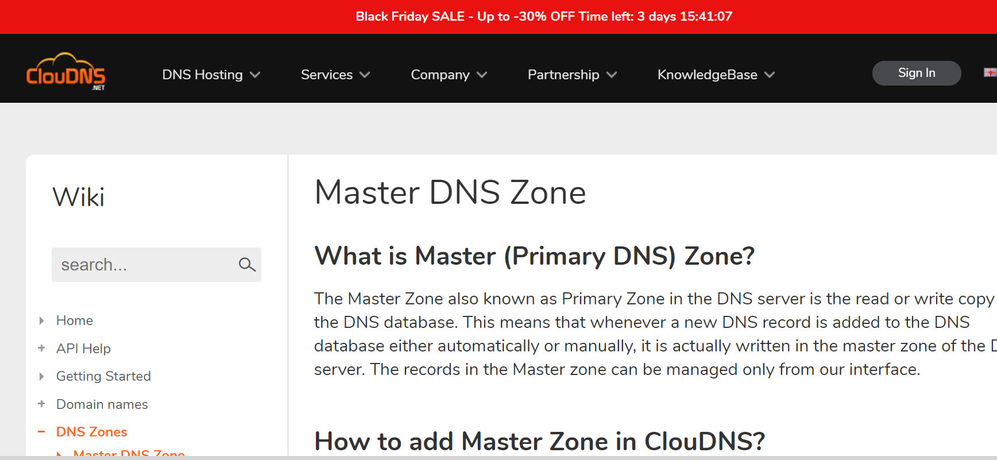webpage

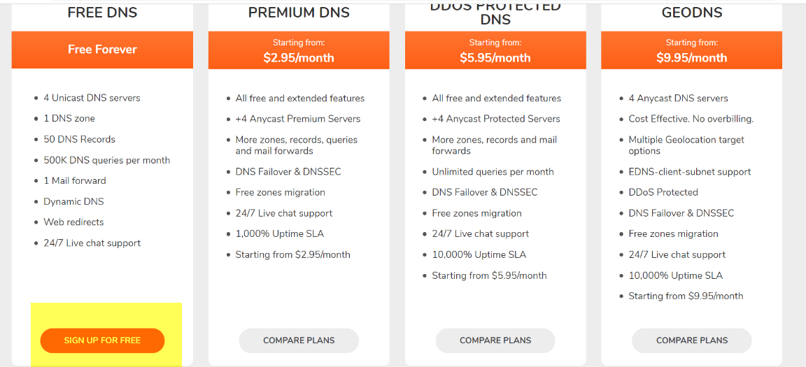2. Select Free DNS -🡪 Sign up for free

3. Input the detail

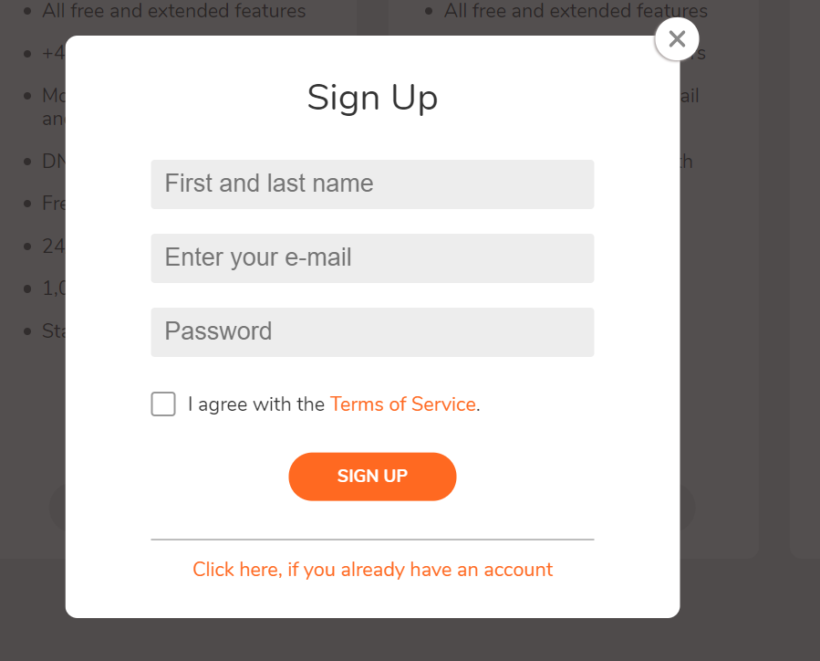

4. Screen for ClounDns and Select DNS Zones (Add new)

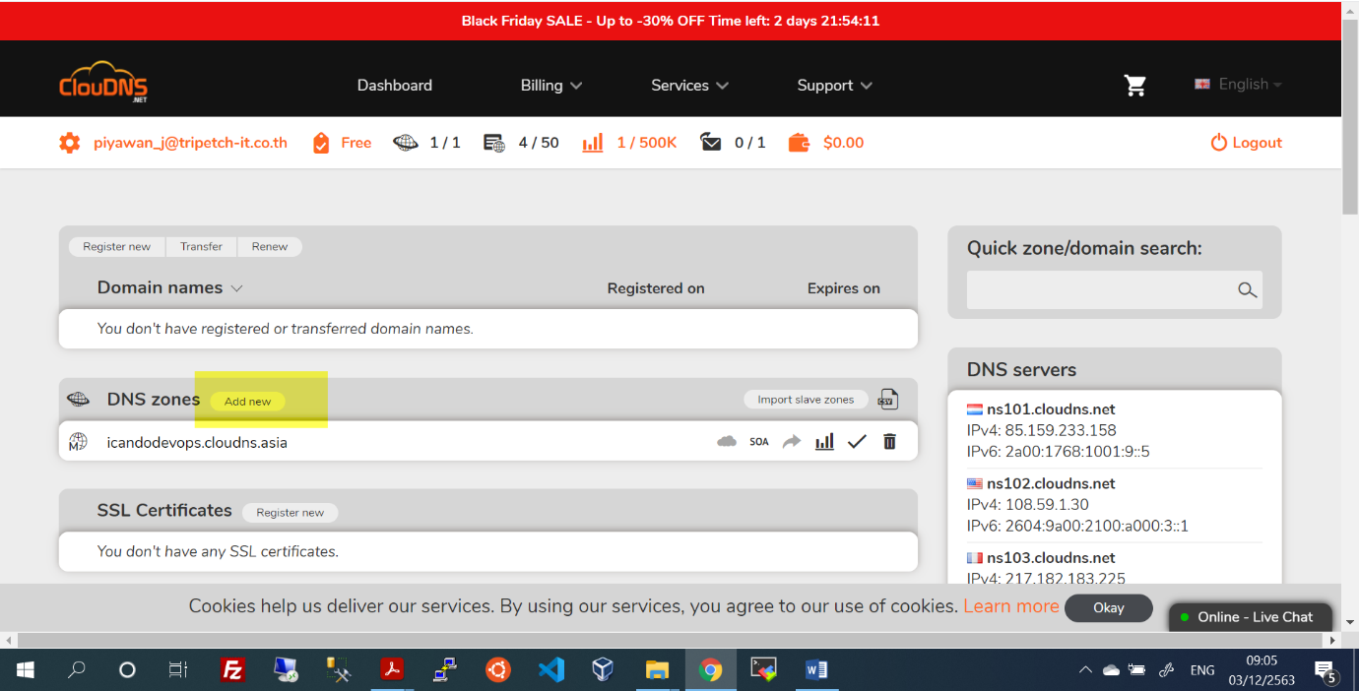

5. Select Free zone

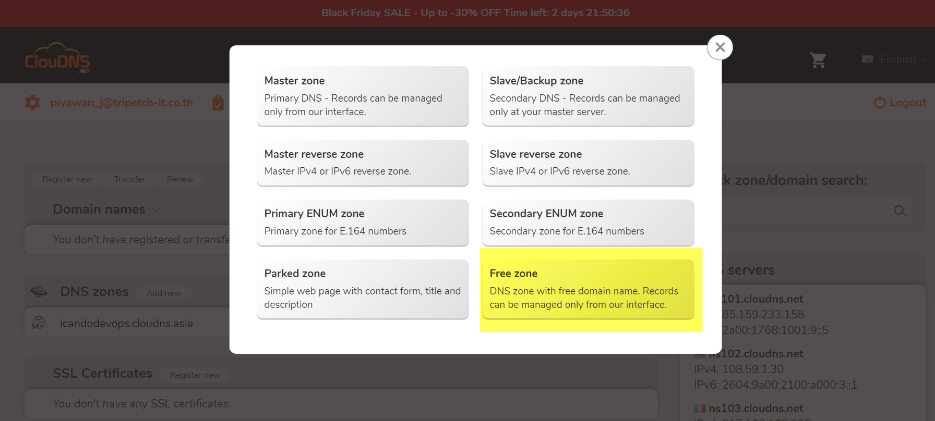

6. Input the detail

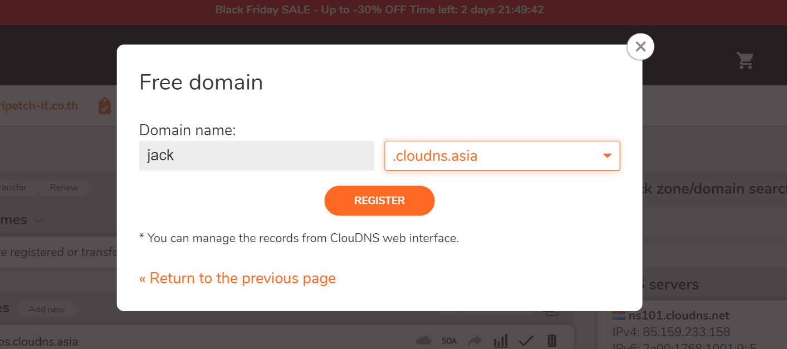

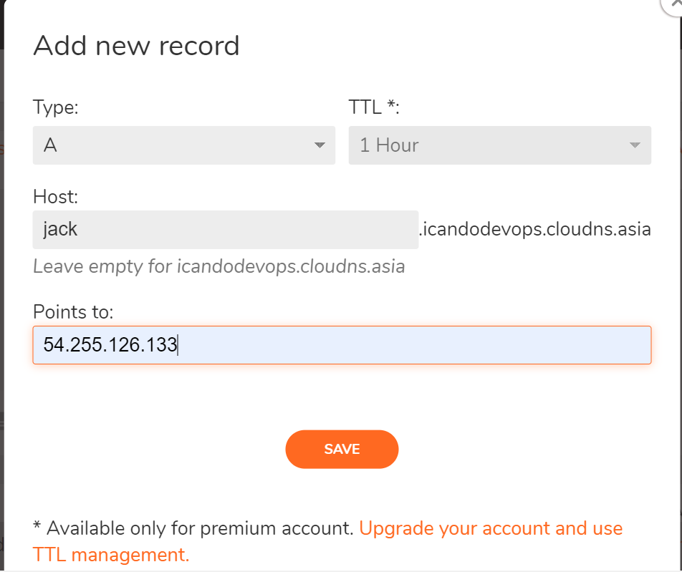7. Select A type and Input the detail for Host name and Input IP for Points to:

8. คู่มือการสร้าง Lightsail ดูของพี่ซุป

https://github.com/supiwmi/Digital/blob/main/1-How%20to%20installl%20Wordpress%20in%20Lightsail.md